10 B DIYS Level 1
Complete ONE of the following using the vocabulary terms below:
Vocabulary foldable, flash cards, matching vocabulary sets, Frayer model cards
Vocabulary Terms:
Phloem, xylem, plantlet, rhizome, runner, geotropism, hydrotropism, phototropism, thigmotropism, stem, root, root hair, leaves, epidermal cell, stomata, shoot, guard cell, cuticle, mesophyll cell

10 B DIYS Level 2
Watch the Amoeba Sisters video (Plant Structure and Adaptation) and ONE of the following:
- Biology text book work: Read Chapter 22 and complete the following in your notebook
  - Pg. 638 #1-7
  - Pg. 647 #1-6
  - Pg. 651 #1-4
- Interactions Among Plant Systems Activity (manila envelope) Answers are written in your notebook.

10 B DIYS Level 3
Complete ONE of the following:
Create an ornament about tropisms and what parts they effect of plants. | Create a song/rap about tropisms and what parts they effect of plants.  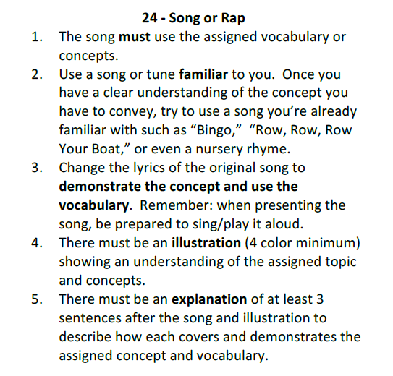 | Create an album cover about tropisms and what parts they effect of plants.  