Biology STAAR Review Activities
Day 1

Category #1 Cell Structure and Processes (4.A, 4.B, 4.C)
4.A compare and contrast prokaryotic and eukaryotic cells;
4.B investigate and explain cellular processes, including homeostasis, energy conversions, transport of molecules, and synthesis of new molecules
4.C compare the structures of viruses to cells, describe viral reproduction and describe the role of viruses in causing diseases such as human immunodeficiency virus (HIV) and influenza.

 | 4.A | 4.B | 4.C
Interactive Quizzes | Structures and Organelles  http://glencoe.mcgraw-hill.com/sites/0078802849/student_view0/unit2/chapter7/section3/self-check_quizzes-english.html | Cellular Transport  http://glencoe.mcgraw-hill.com/sites/0078802849/student_view0/unit2/chapter7/section4/self-check_quizzes-english.html | Viruses and Bacteria  http://www.braingle.com/trivia/17880/viruses-and-bacteria.html
Prokaryote vs. Eukaryote
http://www.proprofs.com/quiz-school/quizshow.php?title=prokaryotic-vs-eukaryotic-cells&q=6&next=n&sid=60489514

Graphic Organizers | Create a Venn Diagram comparing prokaryotic and eukaryotic cells.  See handout | Cell Processes Matching-Match up titles to the appropriate descriptions of cell processes.  http://www.biologycorner.com/worksheets/cell_membrane_images.html | Make a graphic organizer that compares the structures of a virus and of a cell.  See handout
Virtual Labs | Under What Conditions Do Cells Gain or Lose Water?  http://www.glencoe.com/sites/common_assets/science/virtual_labs/LS03/LS03.html | Osmosis and Diffusion  http://content.bfwpub.com/webroot_pubcontent/Content/BCS_4/Bres1e/Activities/Exercise_5-Activity_3/resources/e5a3.html  Diffusion and Osmosis  http://content.bfwpub.com/webroot_pubcontent/Content/BCS_4/Bres1e/Activities/Exercise_5-Activity_3a/Diffusion.html | Making Vaccines  http://www.pbs.org/wgbh/nova/bioterror/vaccines.html
Vocabulary | Cell Structure and Function Flashcards  http://quizlet.com/172368/chapter-7-cell-structure-and-function-flash-cards/ |  | Viruses  http://quizlet.com/35592660/viruses-flash-cards/
Video Clips | Prokaryotic and Eukaryotic Cell Video  http://www.youtube.com/watch?v=ruBAHiij4EA | Membranes and Transport Video  https://www.youtube.com/watch?v=dPKvHrD1eS4&edufilter=_2nXFUMaB1_cnY78uKT5qQ | Viruses  http://www.wimp.com/virusinvades/

4.A, 4.B, 4.C Critical Thinking Questions
Write answers in your notebook!!!!!!

1. What are the differences and similarities between prokaryotic and eukaryotic cells (4A)?

2. How does the structure of the cell membrane relate to it’s function (4B)?

3. How can you evaluate the movement of molecules across a biological membrane (4B)?

4. Discuss how a cell maintains homeostasis (4B).

5. How does virus structure relate to function (4C)?

6. Explain how viruses reproduce, both cycles (4C).

7. Describe how some diseases are caused by viruses (4C)?

4.A Graphic Organizer

Create a Venn Diagram comparing prokaryotic and eukaryotic cells. Include the following terms:

Eukaryotic Cells
Prokaryotic Cells

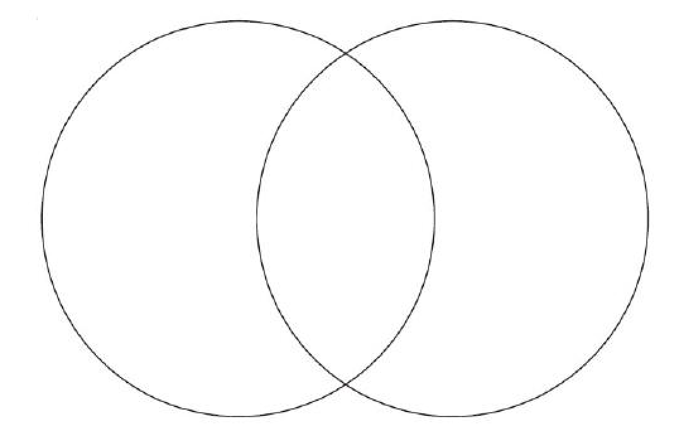

Word Bank
nucleic acids, nucleus, DNA, nuclear membrane, Cell membrane, Membrane bound organelles, Ribosomes, Mitosis, Binary Fission,
Large, Small, RNA, Regulate the flow of nutrients and waste

Helpful links:
http://www.invive.com/cells.html
http://etap.org/demo/biology1/instruction3tutor.html

4.C Graphic Organizer

Viruses and Cells
Characteristic | Virus  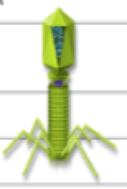 | Cell  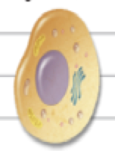
Structure | DNA or RNA in capsid
Reproduction |  | Divides on own; asexually or sexually
Genetic Code |  | DNA
Growth and Development | No
Obtain and Use Energy |  | Yes
Response to Environment | No
Change Over Time | Yes

