Biology STAAR Review Stations
Day 10

Category # 4 Biological Processes and Systems (10.A, 10.B, 10.C)

10.A describe the interactions that occur among systems that perform the functions of regulation, nutrient absorption, reproduction, and defense from injury or illness in animals
10.B describe the interactions that occur among systems that perform the functions of transport, reproduction, and response in plants
10.C analyze the levels of organization in biological systems and relate the levels to each other and to the whole system

 | 10.A | 10.B |  | 10.C
Interactive Quizzes | Interactions of Body Systems  http://www.proprofs.com/quiz-school/story.php?title=interactions--human-body-systems | Plant Systems Quiz  http://wps.pearsoned.com.au/sf2_2/134/34366/8797822.cw/index.html |  | Levels of Organization  http://www.proprofs.com/quiz-school/story.php?title=levels-organization-quiz
Graphic Organizers | Organ Systems Graphic Organizer  See handout | Interactions of Plant Systems Table  Use the following link to complete the Plant System Table:  http://teacherweb.com/TX/roberteleehighschool/Biology/10B-2-signed.pdf |  | Human Body Graphic Organizer  See handout
Virtual Labs | How does the body protect itself against foreign substance?  http://www.glencoe.com/sites/common_assets/science/virtual_labs/LS27/LS27.html | Exploring Plant Responses  https://www.classzone.com/books/hs/ca/sc/bio_07/virtual_labs/virtualLabs.html |  | Circulatory Physiology  http://www.phschool.com/science/biology_place/labbench/lab10/intro.html
Vocabulary | Homeostasis and the Organization of the Human Body Flashcards  http://www.cram.com/flashcards/homeostasis-and-the-organization-of-the-human-body-406558 |  | Plant Systems Flashcards  http://quizlet.com/10585098/10b-plant-systems-flash-cards/ | Body Systems Flashcards  http://quizlet.com/7294628/human-body-systems-flash-cards/
Video Clips | Nutrient Absorption Video Clip  http://www.educreations.com/lesson/view/nutrient-absorption/2381060/?ref=appemail  Animal Defense Video  http://www.educreations.com/lesson/view/animal-systems-defense-b10a/2388923/?s=E20raS&ref=appemail  Regulation Video  http://www.educreations.com/lesson/view/b10a-regulation/2390272/?s=IvDvPs&ref=appemail  Take notes over the video clips. |  | Plant Reproduction in Angiosperms  http://www.youtube.com/watch?v=HLYPm2idSTE&feature=youtu.be | Human Body Systems: The 11 Champions  https://www.youtube.com/watch?v=nnjmrrQ6xOs

Critical Thinking Questions
Write answers in your notebook!!!!!!!

1. How do systems in animals interact to achieve nutrient management?

2. Which systems in animals interact to achieve reproduction?

3. How do systems in animals interact to protect them from injury or illness?

4. What is the role of homeostasis in system regulation?

5. Describe some of the plant responses to different stimuli.

6. Discuss the organization of the basic unit of life to the most complex body systems.

10.A Organ Systems Graphic Organizer

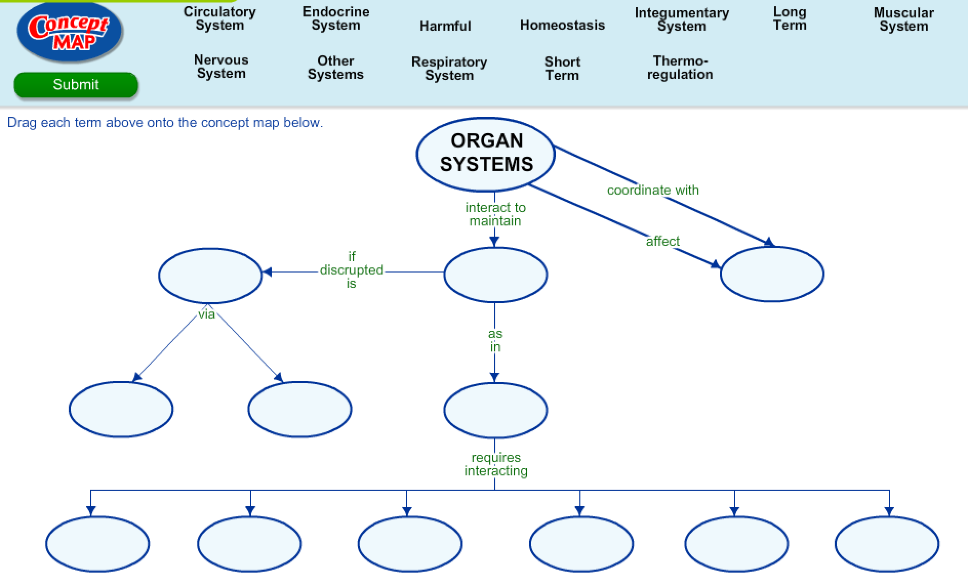

10.B Interactions of Plant Systems Table

Use the following link to describe how plant systems regulate transport, response, reproduction and co-evolution with birds/bugs.
http://teacherweb.com/TX/roberteleehighschool/Biology/10B-2-signed.pdf

Describe how plants regulate the following:
Transport | Response
Reproduction | Co-evolution with birds/bugs

10.C Human Body Graphic Organizer

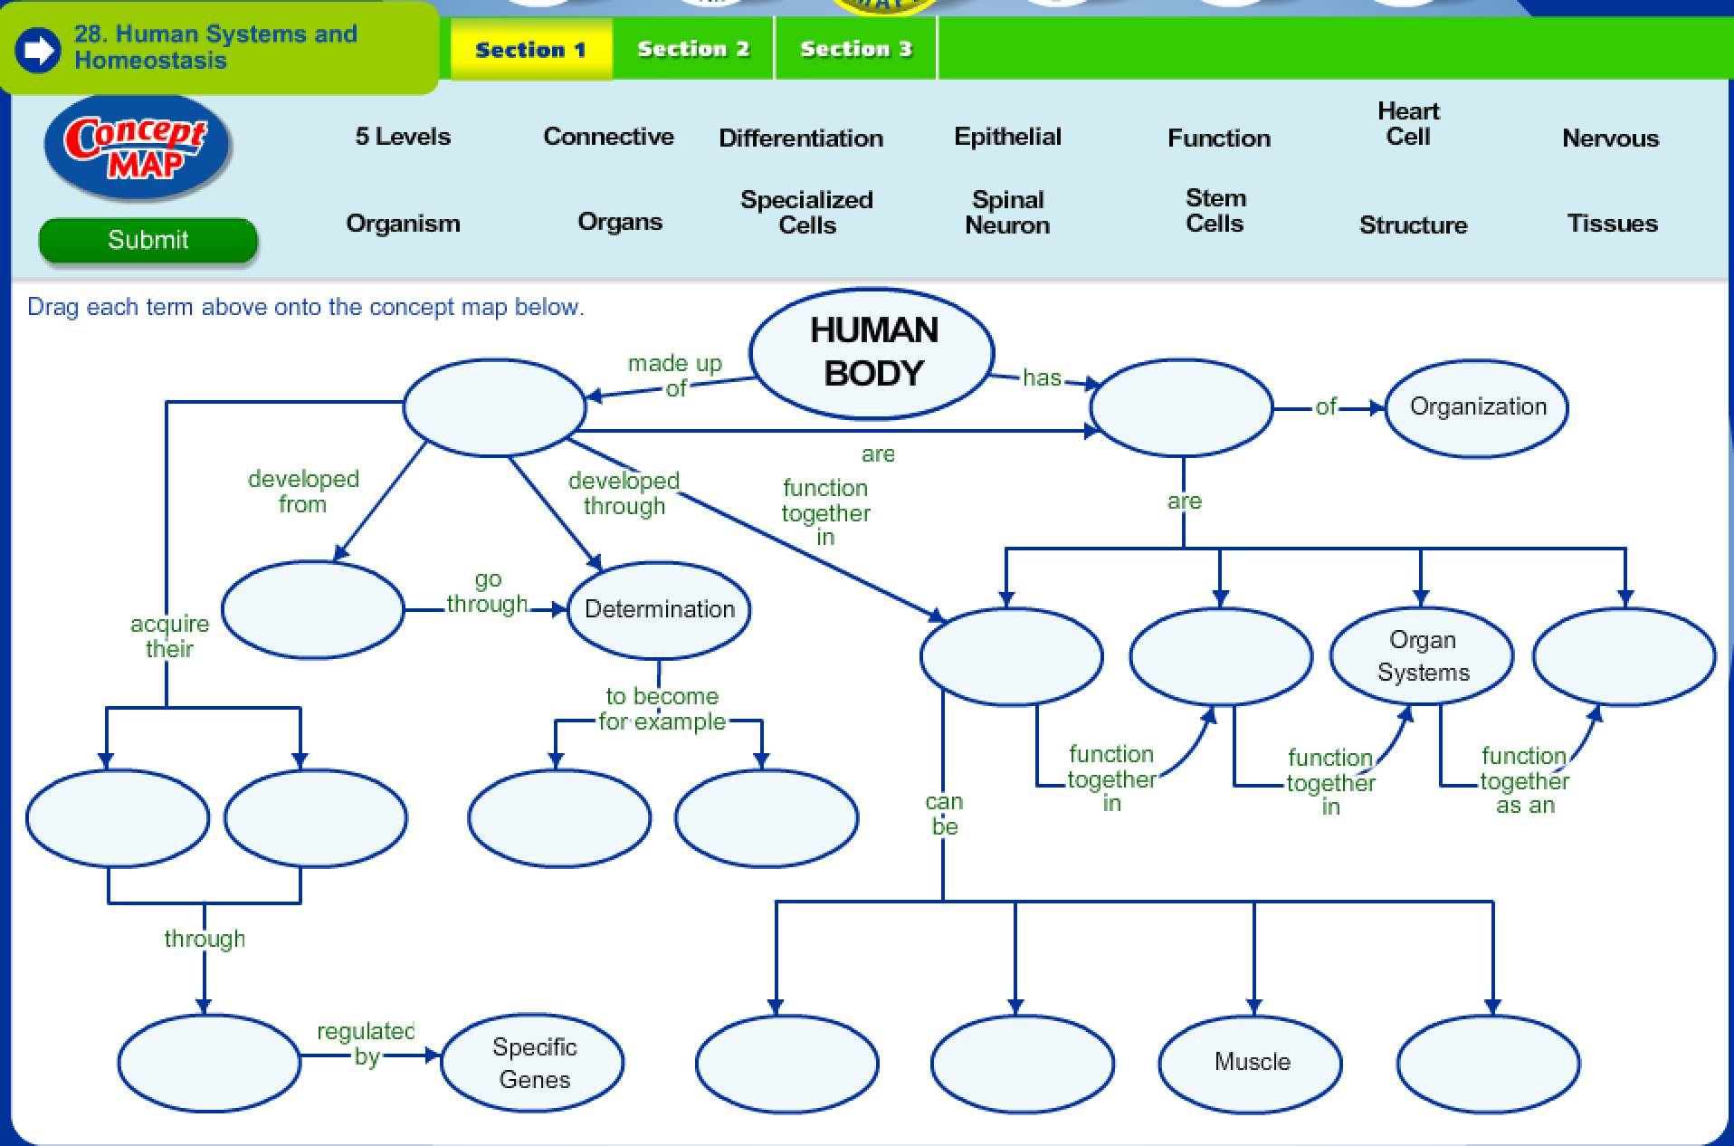

Body System Matching Activity

What do arteries do? | Carry oxygenated blood away from the heart.
What do veins do? | Carry deoxygenated blood to the heart.
What do capillaries do? | They are the smallest vessels that deliver oxygen to individual cells.
What is the function for red blood cells? | Carry oxygen
Why is the red-blood cell shaped like a donut? | The shape allows the cell to carry the maximum amount of oxygen.
Why are cells shaped differently? | The shape of the cell is related to the function of the cell.
What is the function of the air sacs (alveoli) in the lungs? | To gather oxygen from the lungs and carry it to the capillaries.
What are the functions of white blood cells? | Defense, fight pathogens, and are part of the immune system
What causes the disease diabetes? | Blood sugar levels are too high and cannot be controlled.
What are involuntary muscles and give an example. | Muscles that work on their own such as the heart, stomach and intestines.
What are voluntary muscles and give an example. | Muscles that humans can control such as skeletal muscles.
What type of cell carries impulses to and from the brain and spinal cord? | Neurons
During digestion, what is the main function of the large intestine? | Removes water and makes feces
During digestion, what is the main function of the small intestine? | Digestion and absorption of food
During respiration, which gas is removed and exhaled from the body? | Carbon Dioxide
During respiration, which gas is taken into our body? | Oxygen
How do fish control the depth they swim? | The swim bladder aids in controlling the depth.
How do fish “hear”? | Fish have lateral lines that help them “hear”.
What is the autonomic nervous system and what are some functions it controls? | The system works automatically to regulate body temperature and blood sugar levels.
Which system is involved when you experience an “allergy attack”? | The immune system. Symptoms are sneezing and itchy, watery eyes.
What effect does adrenaline (hormone) have on your body when it is released? | “Fight or Flight”—an increase of heart rate, increased blood vessel dilation and increased breathing rate
Which organ releases hormones to control glucose levels in the blood? | Pancreas
Which system is involved with the removal of urea from cells creating urine? | Excretory
Which system is involved with making feces? | Digestive System
If white blood cells attack any of your body cells, what type of disease (category) would that be? | Autoimmune
Which organ removes metabolic wastes from the blood? | Kidneys
What are the sensory organs? | Eyes, skin, tongue, skin and nose
What triggers the “flight-or-fight” response? | Release of hormones and the activation of the sympathetic nervous system

