Biology STAAR Review Stations
Day 11

Category # 4 Biological Processes and Systems (11.B, 11.C, 11.D)

11.B investigate and analyze how organisms, populations, and communities respond to external factors
11.C summarize the role of microorganisms in both maintaining and disrupting the health of both organisms and ecosystems;
11.D describe how events and processes that occur during ecological succession can change populations and species diversity.

 | 11.B | 11.C | 11.D
Interactive Quizzes | How Organisms Interact in Ecosystems  http://highered.mheducation.com/sites/0070947864/student_view0/chapter1/study_quiz_1_2.html | Microorganism Quiz  http://www.kscience.co.uk/revision/microbes/quiz/microbes.htm | Ecological Succession Quiz  http://www.biomanbio.com/Quizzes/EcoQuizzes/EcoQuiz3.html
Graphic Organizers | Community Interactions Graphic Organizers  See handout | Microorganism Graphic Organizer  See handout  For assistance use:  http://www.biology4kids.com/files/micro_main.html | Succession Examples  http://www.geowords.org/ensci/imagesbook/04_03_succession.swf  Draw illustrations of both types of succession.
Virtual Labs | Population Biology  http://glencoe.mcgraw-hill.com/sites/dl/free/0078802849/383928/BL_04.html  Follow the procedure described for the lab.  As you progress throughout the lab, click on the journal questions when prompted and write your answers on the sheet provided. | What Kills Germs  http://www.glencoe.com/sites/common_assets/science/virtual_labs/LS08/LS08.swf | Succession  http://www.mrphome.net/mrp/succession.swf
Vocabulary | Ecology Flashcards  http://quizlet.com/4001657/ecology-flashcards-flash-cards/ | Microorganisms  http://quizlet.com/9272703/microorganisms-flash-cards/ | Ecological Succession  http://quizlet.com/44898092/ecosystems-ecological-succession-flash-cards/
Video Clips | Brain POP Population Growth  http://glencoe.mcgraw-hill.com/sites/dl/free/0078802849/160350/00050757.html  Watch the video and take the quiz | Brain POP Bacteria  http://glencoe.mcgraw-hill.com/sites/dl/free/0078802849/164155/00044676.html  Watch the video and take the quiz  Show quiz results to the teacher. | Succession Animation  http://glencoe.mcgraw-hill.com/olcweb/cgi/pluginpop.cgi?it=swf::550::400::/sites/dl/free/0078802849/383927/A_Climax_Community.swf::A%20Climax%20Community

Critical Thinking Questions

1. What are the effects of environmental changes on populations, species, resources and ecosystems?

2. How do living and non-living organisms interact in ecosystems?

3. What role does bacteria play in maintaining and disrupting the health of organisms?

4. Describe an event in nature that would cause a change in population and species diversity.

11.B Community Interactions Graphic Organizer

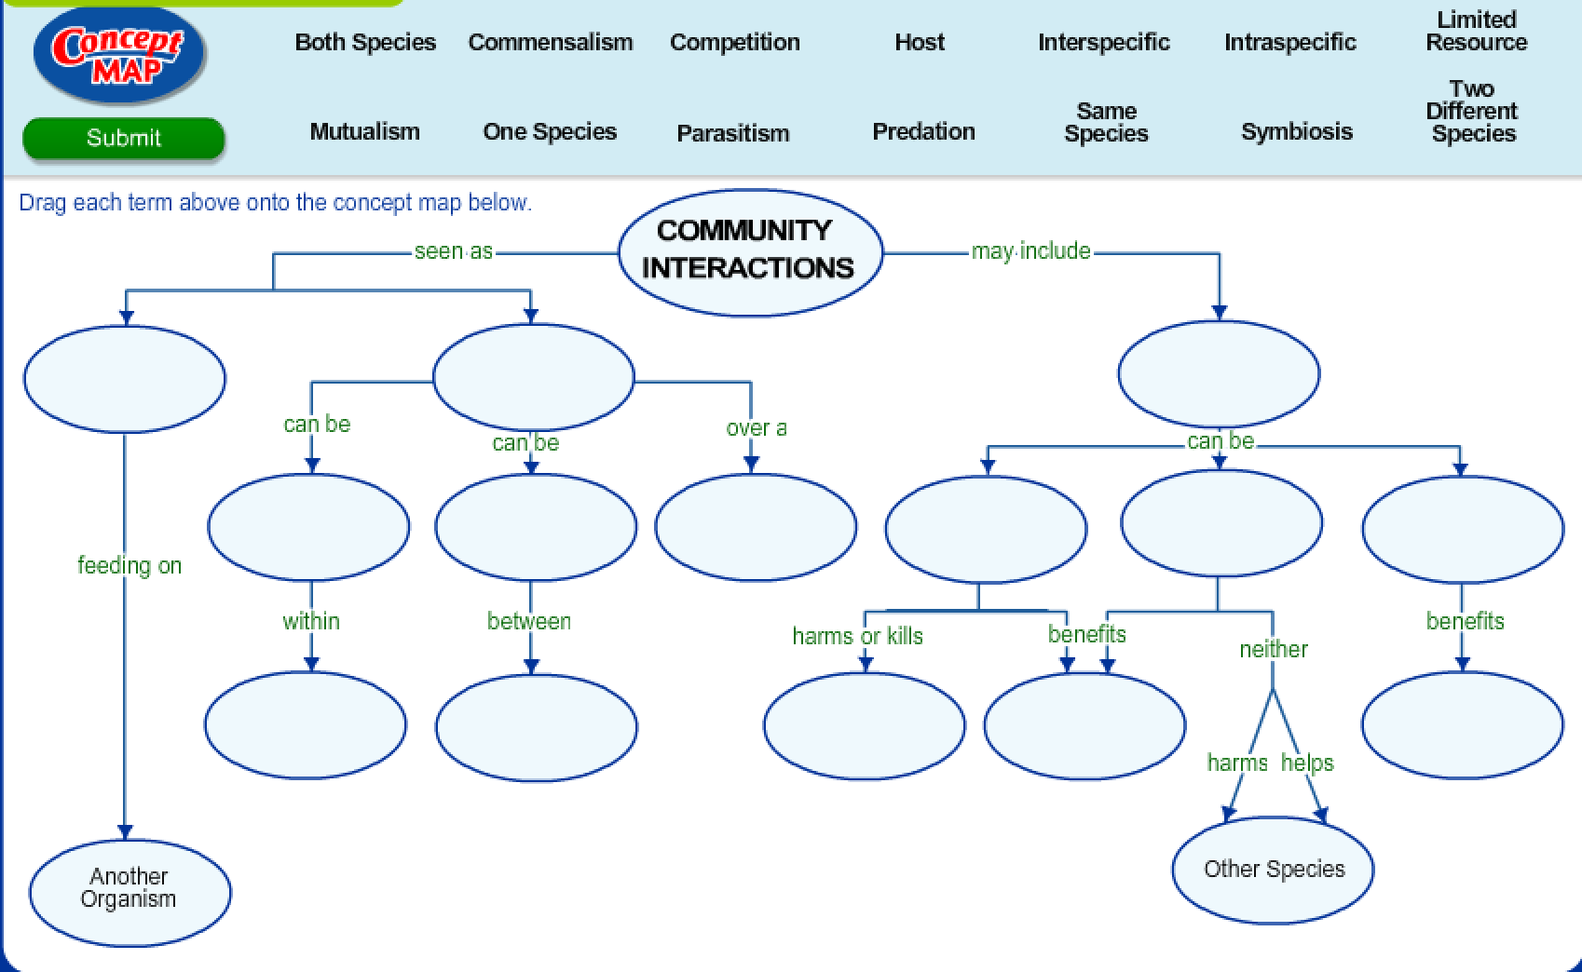

11.C Microorganism Graphic Organizer

What is the role of microorganisms in the living world? Your task is to investigate what a microorganism is, the major characteristics of the five types of microorganisms and where microorganisms can be found in the world. Use http://www.biology4kids.com/files/micro_main.html for assistance.

1. Define microorganism.

2. Below are the 5 major types of microorganisms. For each type, describe or sketch its general appearance and identify specific examples and describe their effect on humans.

Major type of microorganism | General appearance (written description and/or diagram) | Specific examples and their effect on humans
Bacteria

Viruses

Fungi

Algae

Protozoa

Day 11 Review Questions
11.B
_____1. What can be concluded about the relationship between wolves and moose, based on this graph?
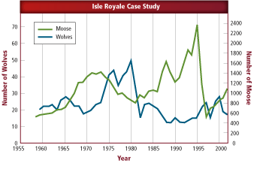
- Wolves prey on moose.
- Moose prey on wolves.
- Wolves and moose do not influence one another.
- Wolves and moose cannot live in the same community.

11.B
_____2. Why don't mice in the wild reproduce at the rate shown in this graph?
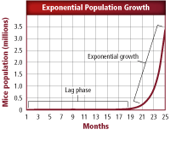
- In the wild, there are no limiting factors present.
- In the wild, resources are unlimited.
- In the wild, resources increase as the population increases.
- In the wild, limiting factors are present.

11.B
_____3. What kind of human population growth is shown between 1000 A.D. and the present?
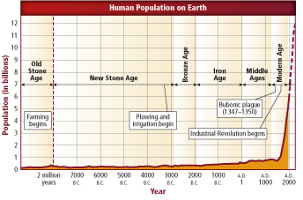
- exponential
- lag
- inverse
- transitional

11.B
____4. Which statement is true based on this picture?
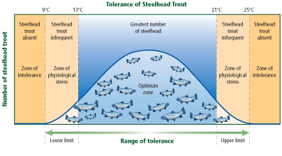
- Temperature does not affect the physiology of steelhead.
- Colder water is always better for steelhead survival.
- Steelhead cannot tolerate temperature above or below a certain limit
- There is no upper limit for steelhead temperature tolerance.

11.C
____5. What is the most important role of fungi in an ecosystem?
- to act as decomposers and recycle nutrients
- to serve as tertiary consumers
- to serve as primary producers
- to act as autotrophs and convert sunlight into glucose and oxygen

11.C
____6. What are two roles bacteria have in the environment?
- fixing nitrogen and decomposing matter
- photosynthesis and respiration
- recycling nutrients and producing oxygen
- fixing nitrogen and producing oxygen

11.C
____7. Bacteria and fungi that help in the breaking down of dead matter and can be found in the carbon cycle:
- producers
- consumers
- decomposers
- pathogens

11.C
____8. Some microorganisms benefit mammals by helping with digestion, while others cause disease. In what manner do bacteria cause disease?
- by taking over the host cells DNA
- by generating heat that kills nearby cells
- by causing cracks in the surface of the skin to allow bacteria to enter
- by damaging tissues and releasing toxins

11.D
_____9. The first organisms to appear during ecological succession are called-------.
- succession plants
- pioneer species
- end point species
- primary organisms
11.D
_____10. What is a climax community?
- stable community with little change in species numbers
- community consisting of pioneer organisms
- community left behind immediately after a forest fire
- community with no biotic factors

11.D
_____11. A biotic or abiotic factor that restricts the numbers of organisms in an ecosystem is called a(n)_________.
- tolerating factor
- limiting factor
- primary succession
- end point
11.D
_____12. One community replacing another as a result of changing aciotic and biotic facotrs is called_______.
- ecological succession
- temperate change
- end point
- tropical succession
Day Eleven Review Questions (11.B, 11.C, 11.D)
Answer Sheet

_____1.
_____2.
_____3.
_____4.

11.B Score_________/4
_____5.
_____6.
_____7.
_____8.

11.C Score_________/4

_____9.
_____10.
_____11.
_____12.

11.D Score_________/4

