Biology STAAR Review Stations
Day 12

Category # 5 Biological Processes and Systems (12.A, 12.B, 12.C, 12.D, 12.E, 12.F)
12.A interpret relationships, including predation, parasitism, commensalism, mutualism, and competition among organisms
12.B compare variations and adaptations of organisms in different ecosystems
12.C analyze the flow of matter and energy through trophic levels using various models, including food chains, food webs, and ecological pyramids
12.D recognize that long-term survival of species is dependent on changing resource bases that are limited
12.E describe the flow of matter through the carbon and nitrogen cycles and explain the consequences of disrupting these cycles
12.F describe how environmental change can impact ecosystem stability

 | 12.A | 12.B | 12.C | 12.D | 12.E | 12.F
Interactive Quizzes | Organisms and Their Relationships  http://www.proprofs.com/quiz-school/story.php?title=organisms-their-relationships | Animal Adaptations  http://www.proprofs.com/quiz-school/story.php?title=animal-adaptations_1 | Ecological Communities  http://www.proprofs.com/quiz-school/story.php?title=53-quiz-ecological-communities |  |  | Principles of Ecology Quiz  http://glencoe.mcgraw-hill.com/sites/0078802849/student_view0/unit1/chapter2/standardized_test_practice-english.html
Virtual Labs | Modeling Ecosystems Virtual Lab  http://glencoe.mcgraw-hill.com/sites/dl/free/0078802849/383926/BL_02.html  Follow the procedure described in the left column. Complete the journal questions. |  | Ecosystems, Organisms and Trophic Levels Virtual Lab  http://glencoe.mcgraw-hill.com/sites/dl/free/0078802849/383916/BL_03.html  Check out the journal information and the diagrams.  Follow the procedure for the activity. |  | Nitrogen/Carbon Cycle Video Clip and Matching Exercise  Watch the following video clip:  http://www.youtube.com/watch?v=XhR1IEbEops  Next match up the appropriate title, description and illustration of each of the cycles. | Communities and Biomes  http://glencoe.mheducation.com/sites/dl/free/0078802849/383927/BL_24.html
Vocabulary | Symbiotic Relationships  http://quizlet.com/11750433/organism-relationships-flash-cards/ | Animal adaptations  http://www.quia.com/jg/2373list.html | Trophic Levels  http://quizlet.com/11177356/trophic-levels-flash-cards/ | Adaptation and Survival  http://quizlet.com/18493686/adaptation-and-survival-flash-cards/ | Biogeochemical Cycles  http://quizlet.com/8970300/biogeochemical-cycle-vocab-flash-cards/ | Ecosystem Stability  http://quizlet.com/30241195/ecosystem-stabilityecological-succession-flash-cards/
Video Clips | Symbiotic Relationships  http://education-portal.com/academy/lesson/symbiotic-relationships-mutualism-commensalism-amensalism.html | Top Ten Animal Adaptations  http://www.animalplanet.com/wild-animals/animal-adaptations.htm | How Ecosystems Work: Energy Flow  http://www.youtube.com/watch?v=o_RBHfjZsUQ |  | Biogeochemical Cycles  http://www.youtube.com/watch?v=09_sWPxQymA | Ecological Succession  http://www.youtube.com/watch?v=V49IovRSJDs

Critical Thinking Questions
Write your answers in your notebook!!!!!!

1. How is matter and energy transferred from one trophic level to the next?

2. How do living and non-living organisms interact in ecosystems?

3. What are the effects of environmental changes on populations, species, resources and ecosystems?

4. How does matter flow in the carbon and nitrogen cycle?

5. Compare variations and adaptations of organisms in different ecosystems.

Day 12 Review Questions
12.A
_____1. Which of the following conditions would make an organism mutualistic with a tree and parasitic with fungi?
A)destroys nutrients needed by tree and the fungi.
B)neither helps nor harms tree, but benefits fungi.
C)protects tree bark from insects while depriving fungi of nutrients.
D)gains exposure to sunlight, but has had no effect on the fungi.

12.A
_____2. If a tick is connected to a dog what type of symbiotic relationship is this?

A. | parasitism

B. | commensalism

C. | symbiosis

D. | mutualism

12.A
_____3. A relationship between two or more organisms that live together and benefit from each other.

A. | Biotic

B. | mutualism

C. | symbiosis

D. | predator

12.A
_____4. What significant function can parasitism have in the ecosystem?
A)the formation of lichens
B)benefiting the health of hosts
C)population decrease of an overabundant species
D)increasing habitat size

12.B
_____5. Any variations that makes an organism better suited to its environment
- Evolution
- Variations
- Species
- Adaptations
12.B
_____6. This graph shows that the growth of ____ is decreased by higher temperature.
A)paramecium
B)colpidium
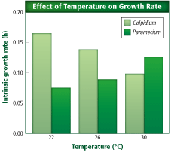
C)colpidium and paramecium
D)neither organism

12.C
_____7. Each step in a food chain or food web is called a (an) ____.
A)trophic level
B)autotroph
C)symbiosis
D)biogeochemical cycle

12.C
_____8. A ____ is a model representing energy flow and interconnected food chains in an ecosystem.
A)population web
B)trophic level
C)biomass indicator
D)food web

12.C
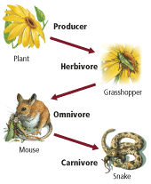
_____9. What does this figure (to the right) show?
A)energy flow from heterotrophs to autotrophs
B)energy flow from autotrophs to heterotrophs
C)a food chain involving only autotrophs
D)a food chain involving only heterotrophs

12.C
_____10. Which statement is true regarding energy, according to this ecological pyramid?
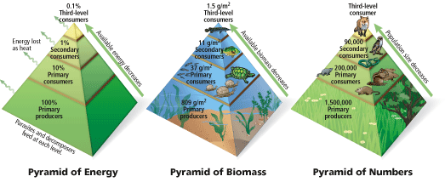
A)No heat energy is lost in an ecosystem.
B)There are fewer primary producers than secondary consumers.
C)There is more available energy in secondary consumers than primary consumers.
D)Ninety percent of the energy is transformed at each level.

12.D
_____11. Long term survival of a species is dependent upon which of the following:
- its ability to absorb sunlight to stay warm
- its ability to adapt to changing resources
- its ability to photosynthesize
- its ability to move

12.E
_____12. The exchange of matter through abiotic factors and organisms is called the ____.
A)carbon cycle
B)nutrient web
C)biogeochemical cycle
D)phosphorus cycle

12.E
_____13. This picture represents the nitrogen cycle. What can be concluded based on this information?
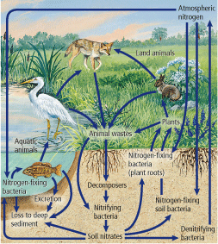
A)Nitrogen never enters plant roots.
B)Animals have no function in the cycle.
C)The cycle takes place primarily on land.
D)Bacteria is important in the cycle.

12.E
_____14. Based on this depiction of the carbon cycle, which of the following statements is true?
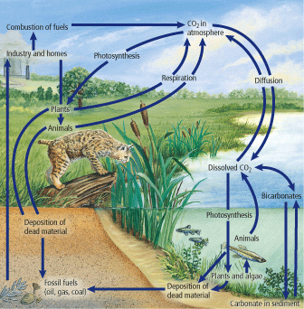

A)Dead material is of no use in an ecosystem.
B)Carbon is a source of fossil fuels.
C)Carbon dioxide (CO2) is never released from the atmosphere.
D)Animals are not incorporated in the cycle.

12.E
_____15. What are two crucial functions of the carbon cycle?
A)keeps carbon dioxide from escaping atmosphere and slows diffusion.
B)prevents bicarbonates formation and slows photosynthesis.
C)provides fossil fuels and recycles carbon dioxide
D)prevents carbon dioxide from entering atmosphere and dissolves fossil fuels.

12.F
_____16. One community replacing another as a result of changing abiotic and biotic factors is called ____.
A)ecological succession
B)temperate change
C)end point
D)tropical succession

Day Twelve Review Questions (12.A, 12.B, 12.C, 12.D, 12.E, 12.F)
Answer Sheet

_____1.
_____2.
_____3.
_____4.
12.A Score_________/4

_____5.
_____6.
12.B Score_________/2

_____7.
_____8.
_____9.
_____10.
12.C Score_________/4

_____11.
12.D Score_____/1

_____12.
_____13.
_____14.
_____15.
12.E Score_____/4

_____16.
12.F Score_____/1

