Biology STAAR Review Stations
Day 2

Category #1 Cell Structure and Processes (5.A, 5.B, 5.C, 5.D)
5.A describe the stages of the cell cycle, including deoxyribonucleic acid (DNA) replication and mitosis, and the importance of the cell cycle to the growth of organisms;
5.B examine specialized cells, including roots, stems, and leaves of plants; and animal cells such as blood, muscle, and epithelium;
5. C describe the roles of DNA, ribonucleic acid (RNA), and environmental factors in cell differentiation;
5. D recognize that disruptions of the cell cycle lead to diseases such as cancer.

 | 5.A | 5.B | 5.C | 5.D
Interactive Quizzes | Mitosis and Cytokinesis  http://glencoe.mcgraw-hill.com/sites/0078802849/student_view0/unit2/chapter9/section2/self-check_quizzes-english.html | Plant and Animal Cells  http://www.proprofs.com/quiz-school/story.php?title=plant-and-animal-cells-quiz_1 | Cellular Reproduction  http://glencoe.mheducation.com/sites/0078802849/student_view0/unit2/chapter9/chapter_test_practice-english.html
Graphic Organizers | Cell Cycle and Mitosis Graphic Organizer  See handout | Plant Specialized Cell Foldable  See handout | Cell Cycle Regulation Concept Map  http://www.classzone.com/cz/books/bio_09/resources/htmls/interactive_review/bio_intrev_ch05.html  See handout
Virtual Labs | Determining time spent in different phases of the cell cycle  http://www.biology.arizona.edu/cell_bio/activities/cell_cycle/cell_cycle.html | Virtual Stem Cell Lab  http://virtualstemlab.com/stemcell.html |  | Virtual Lab: Cell Reproduction  http://glencoe.mcgraw-hill.com/sites/dl/free/0078802849/383933/BL_23.html
Vocabulary | Cell Cycle Flashcards  http://quizlet.com/8674960/cell-cycle-flashcards-flash-cards/ | Specialized Cells Flashcards  http://quizlet.com/5857764/specialized-cells-flash-cards/ | Cell Differentiation Vocabulary  See handout | Disruptions to the Cell Cycle Picture Vocabulary  See handout
Video Clips | Cell Cycle Video  http://www.educreations.com/lesson/view/cell-cycle-b5a/2385579/?s=hTlM8x&ref=appemail | Cell Specialization Brain Pop Video  http://glencoe.mcgraw-hill.com/sites/dl/free/0078802849/164155/00035805.html  Specialized Cells and Tissues Video  http://www.youtube.com/watch?v=I8uXewS9dJU | Why RNA is Just as Cool as DNA  http://www.youtube.com/watch?v=0Elo-zX1k8M | The Cell Cycle and Cancer  http://www.youtube.com/watch?v=lpAa4TWjHQ4&feature=youtu.be

5.A, 5.B, 5.C, 5.D Critical Thinking Questions
Write answers in your notebook!!!!!!

- How does mitosis compare to meiosis (5A)?

- What are the characteristic changes of mitosis (5A)?

- What are the characteristic changes in meiosis (5A, 6G)?

- How are cells specialized to carry on their function (5B)? Why are all cells not the same?

- What is the composition of DNA (5C)?

6. How is genetic information carried by DNA (5C)?

- Discuss how a cell may become cancerous (5D).

5.B Plant Specialized Cell Foldable

Use the online lecture link for assistance:
http://www.mhhe.com/biosci/genbio/maderinquiry/lecture/lecture9.html

Fold line Fold line
Plant Structure | Function | Illustration
Leaves

Stems

Xylem

Phloem

Roots

Flowers

5.C, 5.D Cell Cycle Regulation Concept Map

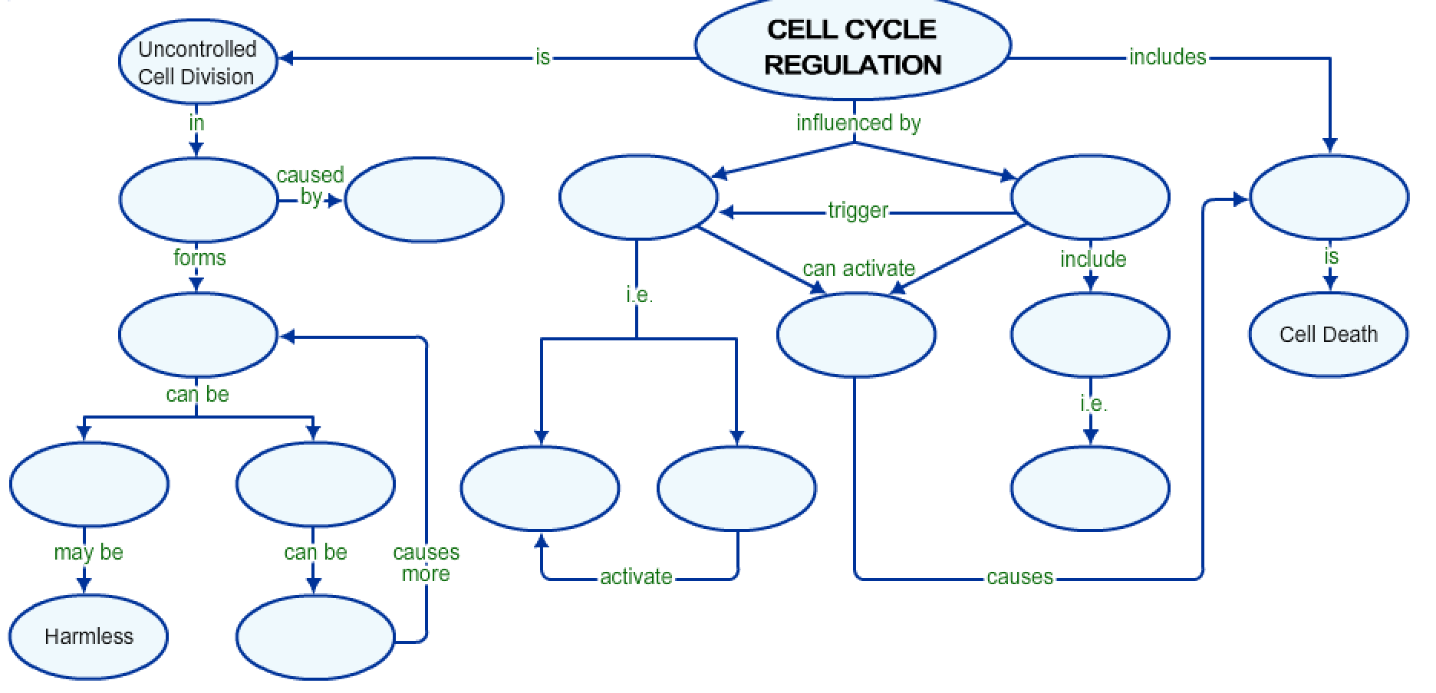
Word Bank
Cancer
Apoptosis
External Factors
Internal Factors
Cyclins
Metastasized
Carcinogens
Tumors
Self Destructive Enzymes
Messages
Growth Factors
Kinases
Malignant
Benign

5.A Cell Cycle and Mitosis Graphic Organizer

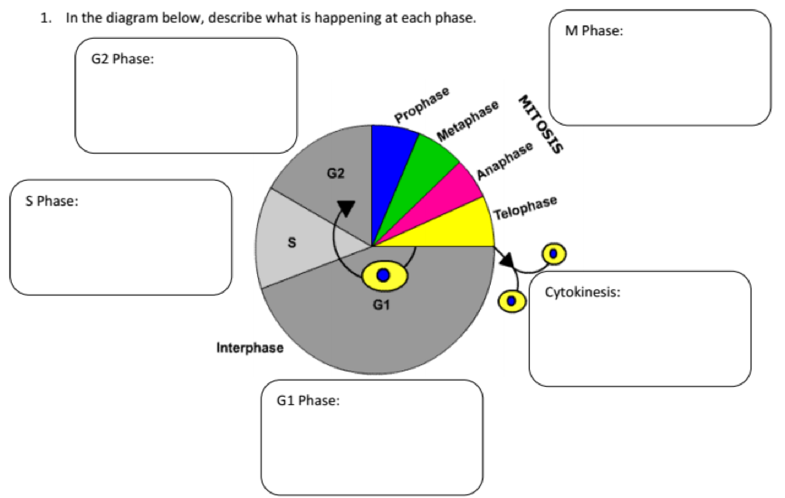

Match the appropriate pictures to the correct phase of mitosis

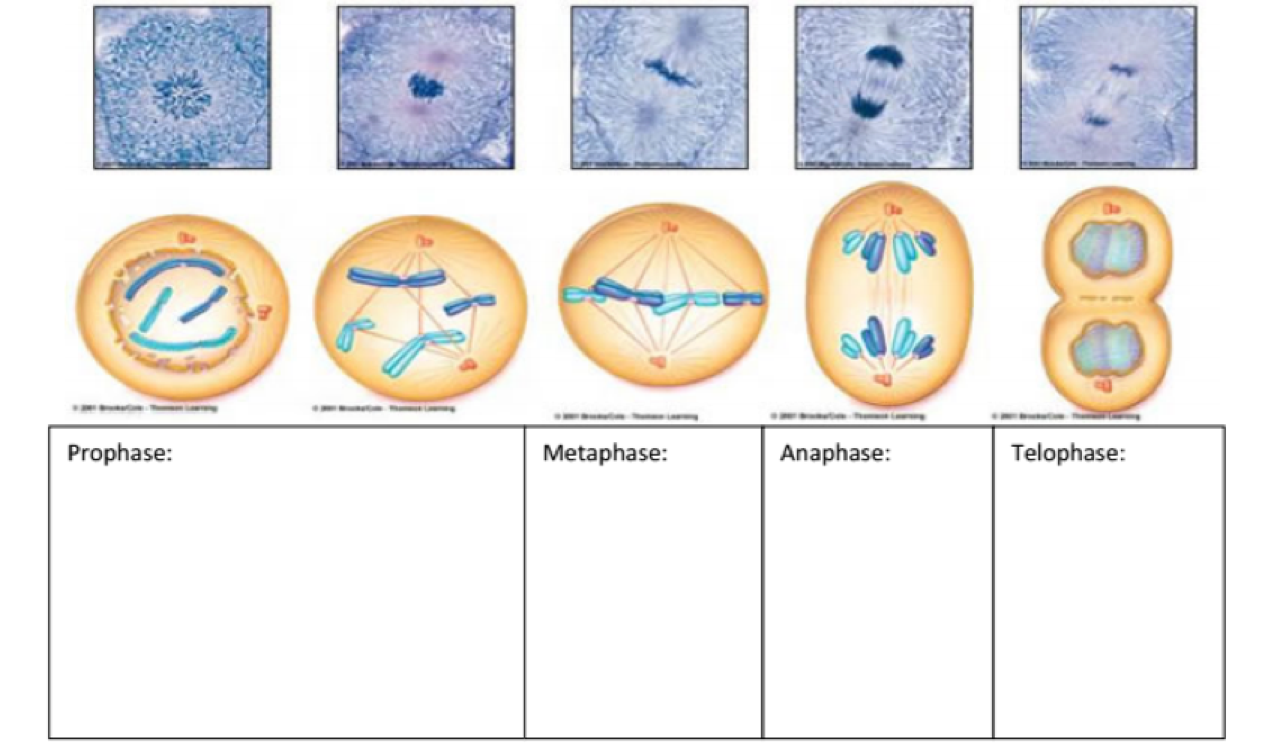

5. C Cell Differentiation Vocabulary

Cell differentiation | The process of generic embryonic cells becoming specialized cells.
Gene expression | The specific combination of genes that are turned on or off (expressed or repressed), and this is what dictates how a cell functions.
Importance of cell differentiation | Cells need to have different structures because they have different functions
DNA replication | The process in which the DNA sequence is  copied to form an additional DNA molecule
Stem Cell | A “blank” cell that can be turned into a variety of different types of cells found in the body
RNA | The biomolecule classified as a nucleic  acid and composed of nucleotides; genetic  material in a single helix form
Mutation | Any change in the sequence of DNA; may result in the production of incorrect proteins and lead to malfunctions in the processes of the organism

5.D Disruptions to the Cell Cycle Picture Vocabulary
Radiation 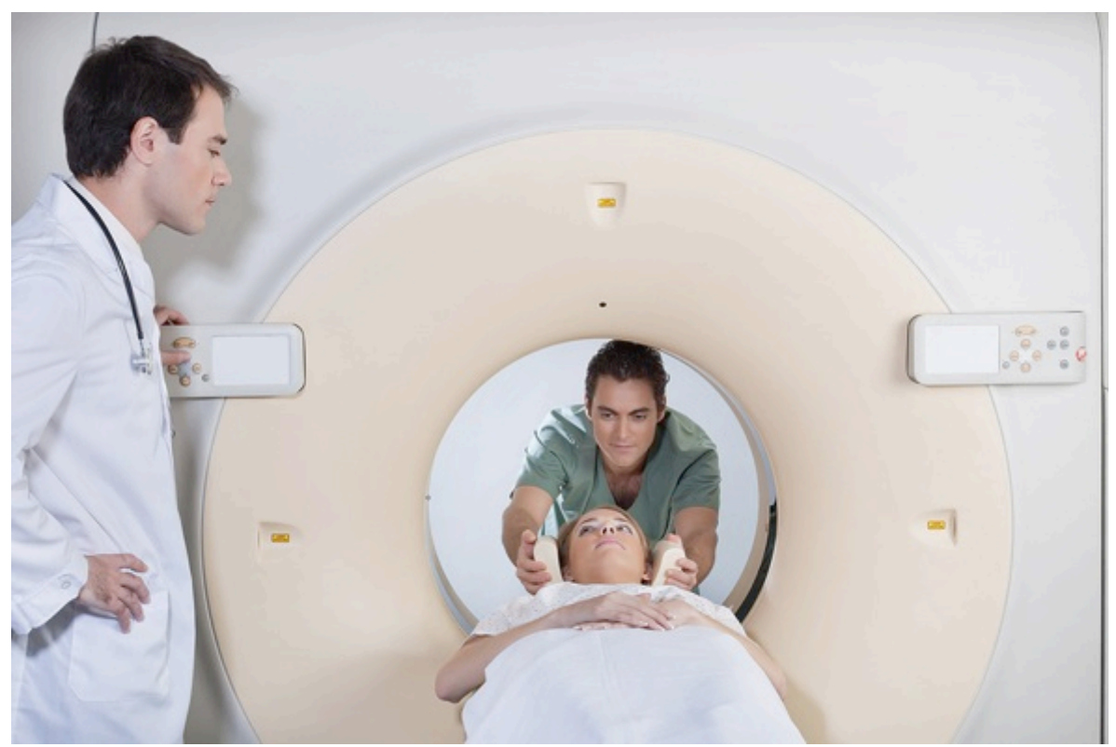
Energy sent out as particles or
waves; used in the treatment of
cancerous tumors

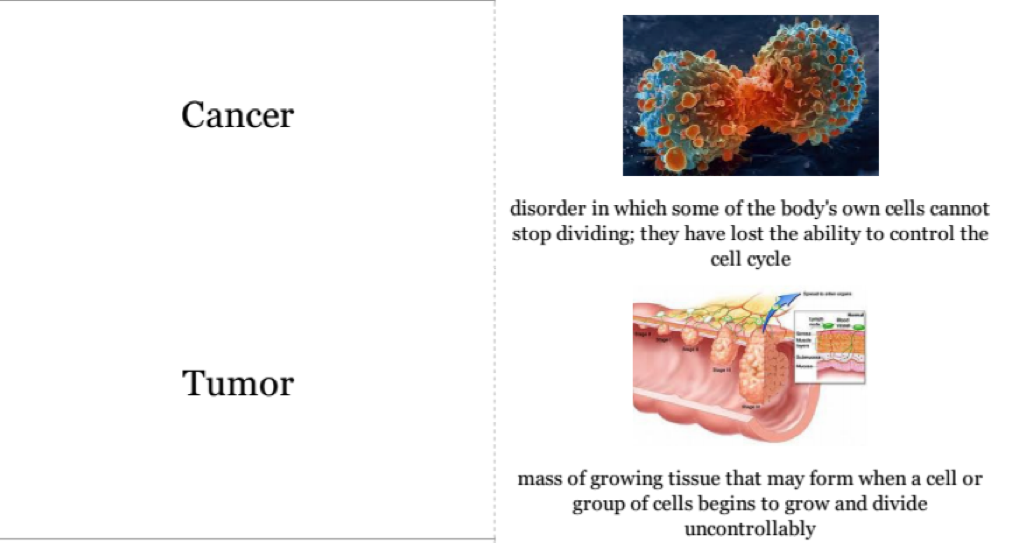

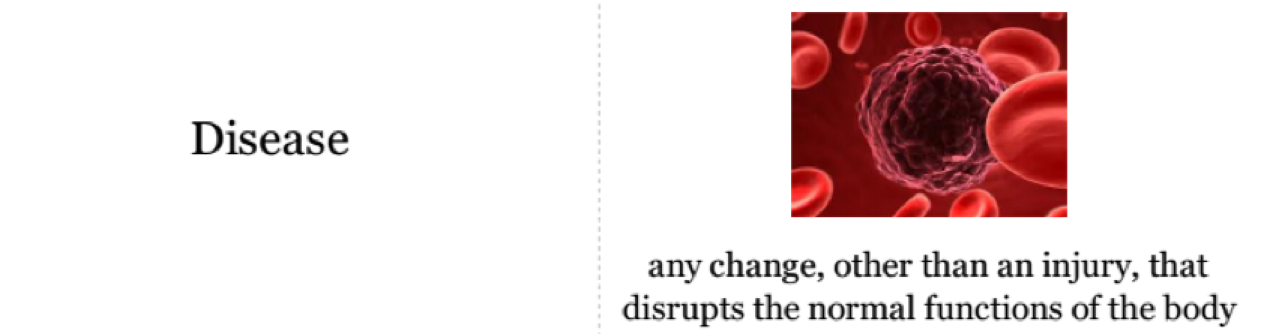
Chemotherapy
The treatment of disease by use of chemicals; can selectively destroy cancerous tissue

