Biology STAAR Review Stations
Day 5

Category # 2 Mechanisms of Genetics (6.E, 6.F, 6.G, 6.H)

6.E identify and illustrate changes in DNA and evaluate the significance of these changes
6.F predict possible outcomes of various genetic combinations such as monohybrid crosses, dihybrid crosses and non-Mendelian inheritance
6.G recognize the significance of meiosis to sexual reproduction
6.H describe how techniques such as DNA fingerprinting, genetic modifications, and chromosomal analysis are used to study the genomes of organisms

 | 6.E | 6.F | 6.G | 6.H
Interactive Quizzes | DNA and Genes  http://www.glencoe.com/qe/science.php?qi=2502 | Mendelian Genetics  http://glencoe.mheducation.com/sites/0078802849/student_view0/unit3/chapter10/section2/self-check_quizzes-english.html | Meiosis  http://glencoe.mheducation.com/sites/0078802849/student_view0/unit3/chapter10/section1/self-check_quizzes-english.html | DNA Fingerprinting Quiz  http://www.quia.com/quiz/447670.html?AP_rand=1093351065
Graphic Organizers | Mutation Graphic Organizer  See handout | Dihybrid Cross Practice Punnet  Square  Activity  See handout | Meiosis Graphic Organizer  See handout | Genetic Variation Graphic Organizer  See handout
Virtual Labs | Damage to DNA Leads to Mutation Simulation  http://www.hhmi.org/biointeractive/damage-dna-leads-mutation  Addition and Deletion Mutations Simulation  http://glencoe.mcgraw-hill.com/olcweb/cgi/pluginpop.cgi?it=swf::550::400::/sites/dl/free/0078802849/592990/Addition_and_deletion_mutations.swf::Addition%20and%20Deletion%20Mutations | Dihybrid Cross Simulation  http://www.dnaftb.org/5/problem.html  Completion_____  Punnet Squares Virtual Lab  http://glencoe.mcgraw-hill.com/sites/dl/free/0078802849/383934/BL_05.html | Meiosis Internet Activity  http://www.lpscience.fatcow.com/jwanamaker/animations/meiosis.html | Create a DNA Fingerprint Virtual Lab  http://www.pbs.org/wgbh/nova/education/body/create-dna-fingerprint.html
Vocabulary | DNA Flashcards  http://quizlet.com/20610090/unit-5-dna-vocabulary-list-flash-cards/ | Mendelian Genetics  Flashcards  http://quizlet.com/1471356/mendelian-genetics-vocabulary-terms-flash-cards/ | Meiosis Flashcards  http://quizlet.com/8869794/meiosis-vocabulary-terms-flash-cards/ | DNA Fingerprinting Flashcards  http://quizlet.com/1823048/dna-fingerprinting-flash-cards/
Video Clips | Mutations: The Potential Power of a Small Change  www.youtube.com/watch?v=GieZ3pk9YVo | Mendelian Genetics  https://www.youtube.com/watch?v=oVl8OH_7QSc | Meiosis the Great Divide  https://www.youtube.com/watch?v=toWK0fIyFlY | DNA Fingerprinting  https://www.youtube.com/watch?v=DbR9xMXuK7c

Critical Thinking Questions
Write answers in your notebook!!!!!!

1. How do changes in DNA affect the resulting protein?

2. What are the implications of these changes?

3. How does mitosis compare to meiosis?

4. How can genetic disorder be detected using different techniques?

5. How do the results of dihybrid crosses express themselves in living organisms?

6. Describe ways to study the genomes of organisms

6.E Mutations Graphic Organizer

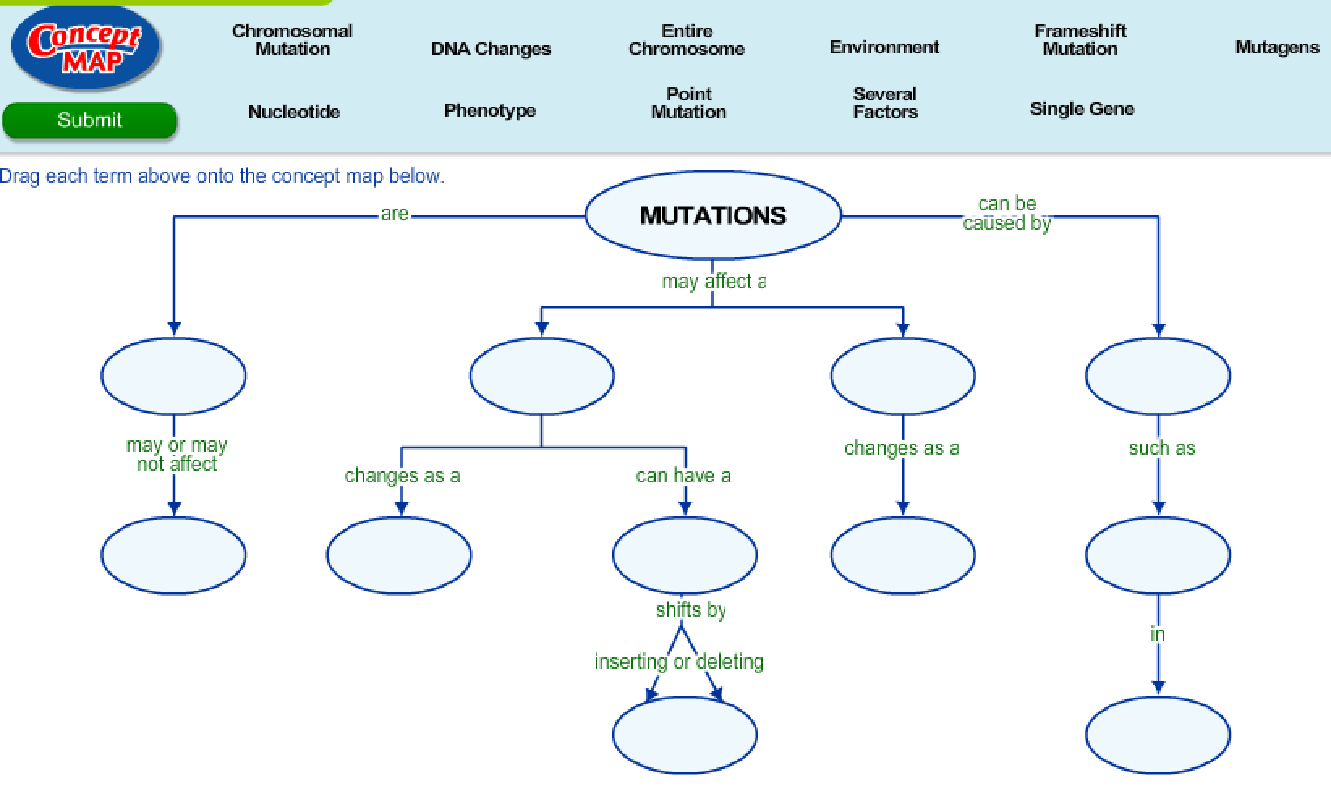

6.G Meiosis Graphic Organizer

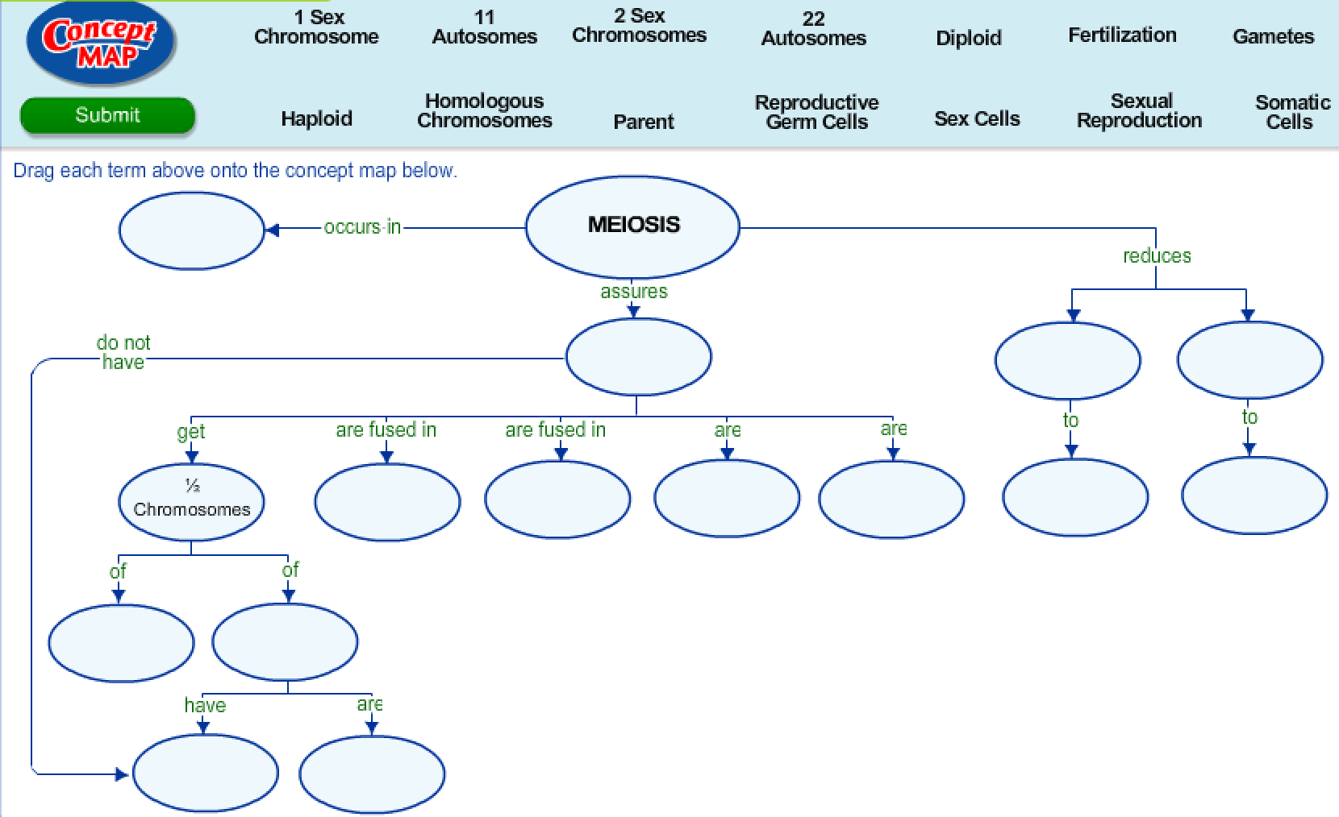

6.F Dihybrid Cross Practice Punnet Square
http://www.biologycorner.com/worksheets/genetics_2traits_bio2.html#.UzWthq1dWMU

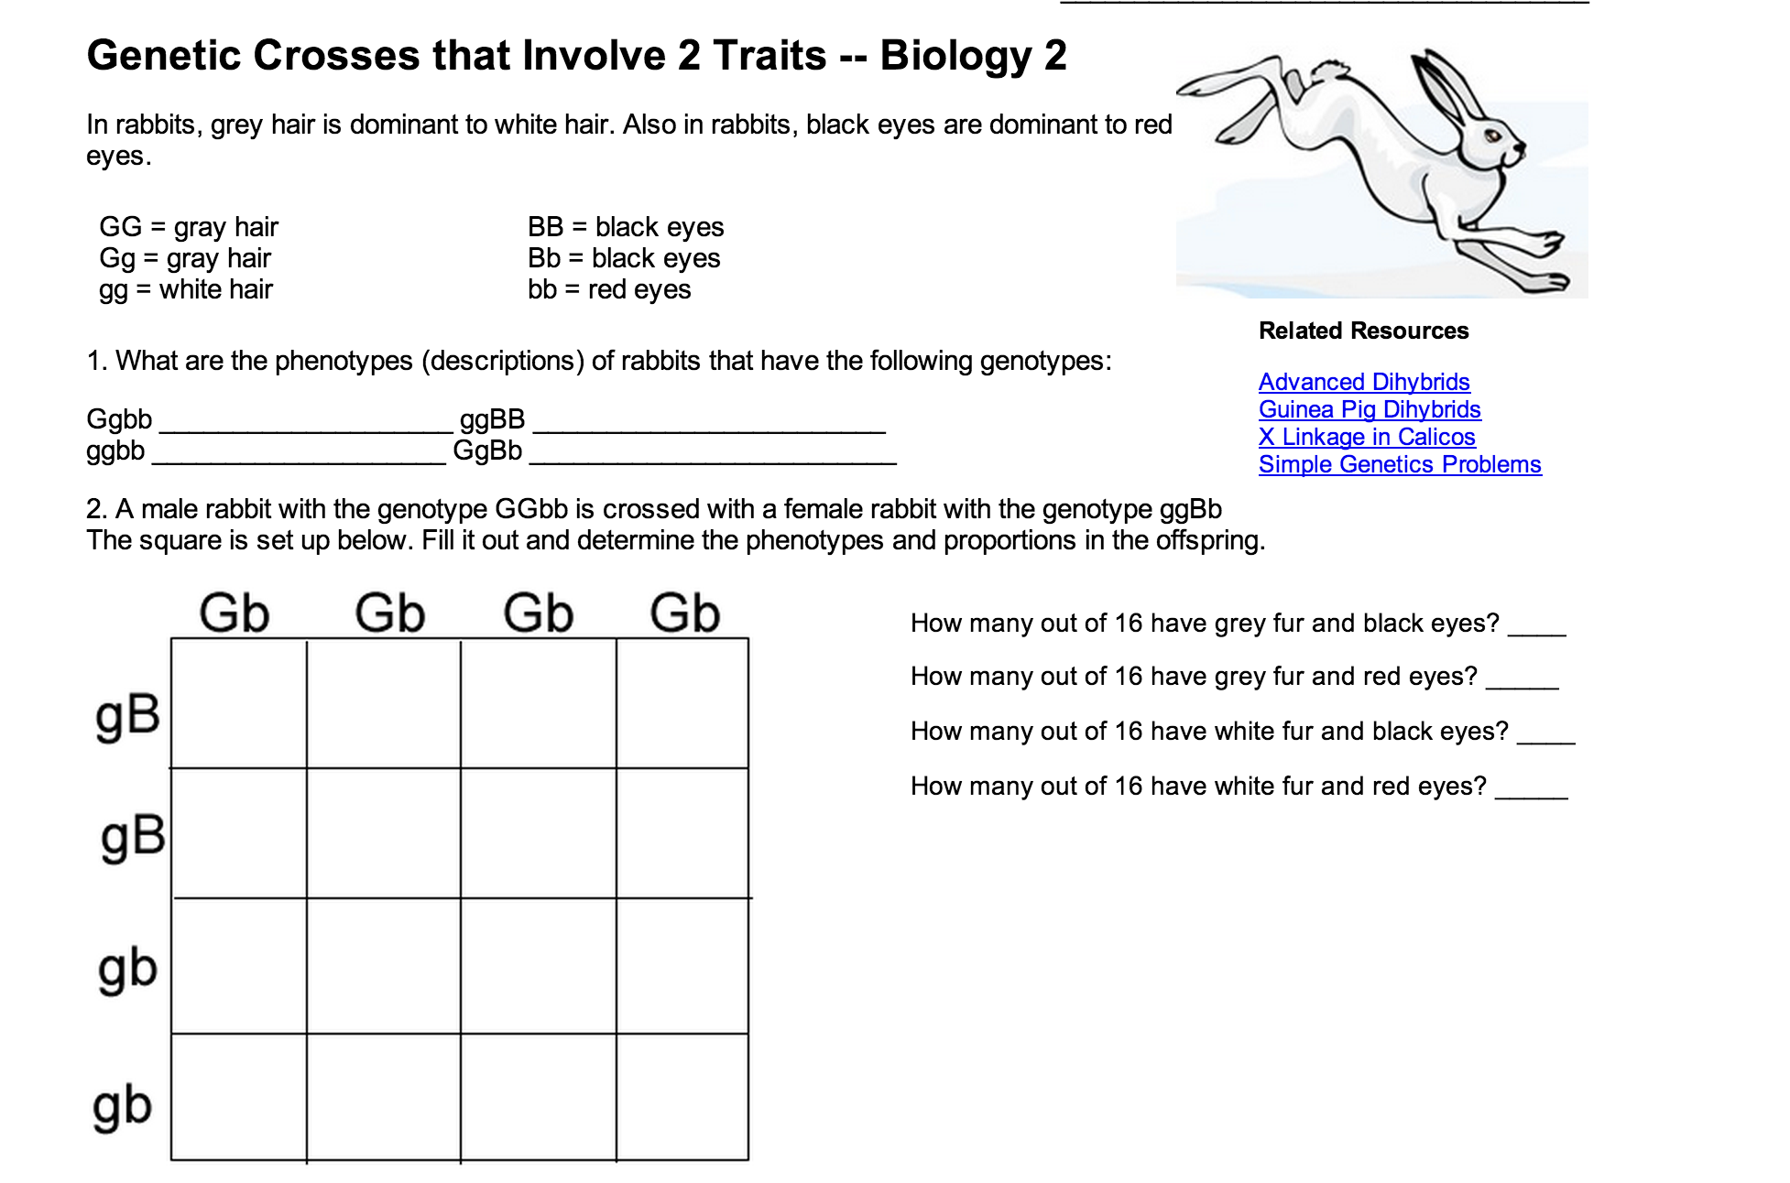

6.H Genetic Variation Graphic Organizer

