Biology STAAR Review Stations
Day 7

Category # 3 Biological Evolution and Classification (7.E, 7.F, 7.G)

7.E analyze and evaluate the relationship of natural selection to adaptation and to the development of diversity in and among species
7.F analyze and evaluate the effects of other evolutionary mechanisms, including genetic drift, gene flow, mutation, and recombination
7.G analyze and evaluate scientific explanations concerning the complexity of the cell

 | 7.E | 7.F | 7.G
Interactive Quizzes | Natural Selection Tutorial and Quiz  http://bcs.whfreeman.com/thelifewire/content/chp23/2302001.html | The Evolution of Organisms  http://nortonbooks.com/college/biology/animations/ch05a09.htm  Go through narration and take the quiz. Show results to the teacher.
Graphic Organizers | Natural Selection Graphic Organizer  See handout | Mechanisms of Evolution  http://evolution.berkeley.edu/evosite/evo101/IIIMechanisms.shtml  Draw pictures of the following mechanisms of evolution:  Descent Genetic Variation  Mechanisms of Change Natural Selection  Genetic Drift Coevolution | Multicellular Life Graphic Organizer  See handout
Virtual Labs | How Can Natural Selection be Modeled?  http://www.glencoe.com/sites/common_assets/science/virtual_labs/LS06/LS06.html | Effects of Other Evolutionary Mechanisms  http://tinyurl.com/lqwrwvh | Natural Selection: Fact or Fiction  http://www.discovery.com/tv-shows/curiosity/topics/natural-selection-quiz.htm
Vocabulary | Animal Adaptation Flashcards  http://quizlet.com/6108125/animal-adaptation-unit-flash-cards/ | Evolutionary Mechanism Flashcards  http://quizlet.com/43997765/bisc-120-evolutionary-mechanisms-flash-cards/ | Cell Complexities Flashcards  http://quizlet.com/52126577/evolutionary-mechanisms-and-cell-complexity-vocabulary-flash-cards/
Video Clips | Animal Adaptations  http://www.youtube.com/watch?v=fRX2JtKFUzk | Mutations: The Potential Power of a Small Change  Watch the video clip at: https://www.youtube.com/watch?v=GieZ3pk9YVo  Complete the video recap handout while you watch. http://amoebasisters.weebly.com/uploads/2/1/9/0/21902384/video_recap_of_mutations_by_amoeba_sisters.pdf | The Endosymbiosis Theory: Evolution of Cells Video and Quiz  http://education-portal.com/academy/lesson/the-endosymbiosis-theory-evolution-of-cells.html#lesson  Watch the video and complete the quiz. Show quiz results to the teacher.

7.E, 7.F, 7.G Critical Thinking Questions
Write answers in your notebook!!!!!!

1. What are the different reasons species are successful today?

2. What are the effects of other evolutionary mechanisms on today’s species?

3. How does natural selection explain how organisms have changed over time?

4. Scientists believe that the eukaryotic cell is made of several other cell types. Discuss evidence of this theory.

5. Discuss explanations over the complexity of the cell

7.E Natural Selection Graphic Organizer

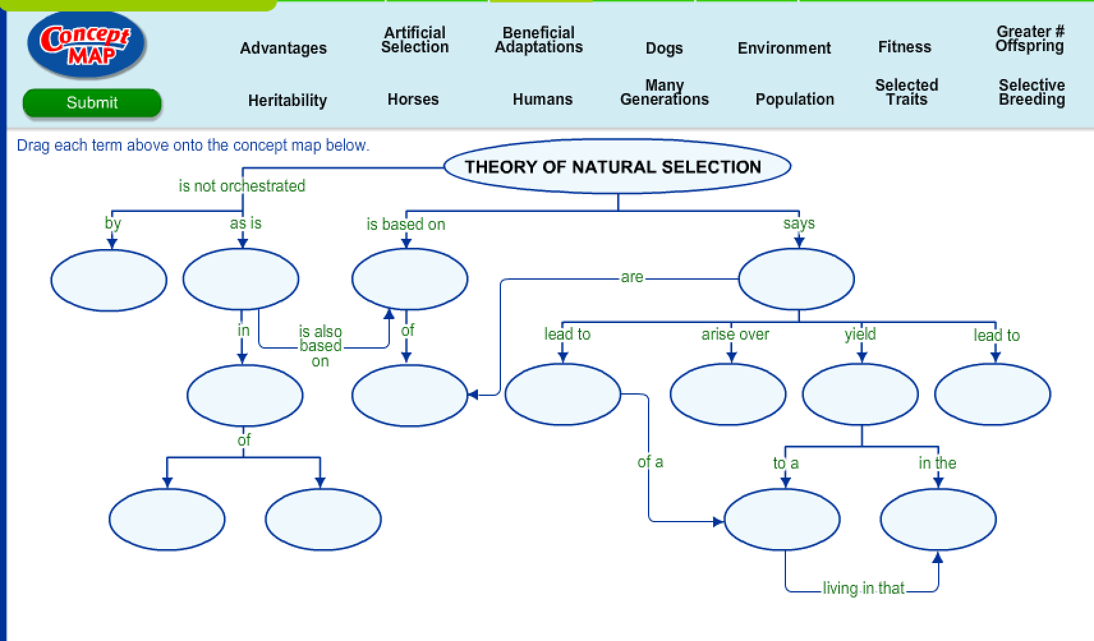

7.F Mechanisms of Evolution Graphic Organizer
Illustrate the following mechanisms of evolution:

Descent

Mechanisms of Change

Genetic Variation

Genetic Drift

Natural Selection

Coevolution

7.G Multicellular Life Graphic Organizer

