Biology STAAR Review Stations
Day 8

Category # 3 Biological Evolution and Classification (8.A, 8.B, 8.C)

8.A define taxonomy and recognize the importance of a standardized taxonomic system to the scientific community.
8.B categorize organisms using a hierarchical classification system based on similarities and differences shared among groups.
8.C compare characteristics of taxonomic groups, including archaea, bacteria, protists, fungi, plants, and animals.

 | 8.A | 8.B | 8.C
Interactive Quizzes | Taxonomy Quiz  http://ab.mec.edu/abrhs/science/bioweb/unit8/quiz_unit_8.html | Organizing Life’s Diversity  http://glencoe.mcgraw-hill.com/sites/0078802849/student_view0/unit4/chapter17/standardized_test_practice-english.html | Kingdom Characteristics Interactive Table  http://glencoe.mcgraw-hill.com/olcweb/cgi/pluginpop.cgi?it=swf::550::400::/sites/dl/free/0078802849/383912/table17_3.swf::Kingdom%20Characteristics
Graphic Organizers | Linnean Classification Graphic Organizer  See handout |  | Three Domains Graphic Organizer  See handout
Virtual Labs | How are living things classified?  http://www.glencoe.com/sites/common_assets/science/virtual_labs/E07/E07.swf | Evolutionary Trees Simulation  http://glencoe.mcgraw-hill.com/olcweb/cgi/pluginpop.cgi?it=swf::550::400::/sites/dl/free/0078802849/383941/Evolutionary_Trees.swf::Evolutionary%20Trees  Watch the simulation and take a few notes. | Dichotomous Key Activity  http://web.archive.org/web/20080721211717/http://www.students.ed.qut.edu.au/n2364379/MDB377/DichotomousKey.html  Choose at least two animals from the group to classify using the dichotomous key.  Show results to the teacher.
Vocabulary | Taxonomy  http://quizlet.com/20531643/biology-taxonomy-flash-cards/ | Classification  http://quizlet.com/1934970/classification-flash-cards/ | Taxonomic Groups  http://quizlet.com/35058554/taxonomic-groups-flash-cards/
Video Clips | Taxonomy and the Tree of Life  https://www.khanacademy.org/science/biology/tree-of-life/v/taxonomy-and-the-tree-of-life | Classification Overview Video  http://www.youtube.com/watch?v=bZ8AUcbZOLY&edufilter=_2nXFUMaB1_cnY78uKT5qQ  Take notes over the video while you watch.  The Tree of Life Animation  http://glencoe.mcgraw-hill.com/olcweb/cgi/pluginpop.cgi?it=swf::550::400::/sites/dl/free/0078802849/383941/Visualizing_Tree_Life.swf::Visualizing%20the%20Tree%20of%20Life  Watch the animation and take a few notes. Pause periodically to allow more time. | Six Kingdoms Brain Pop Video and Quiz  Watch the video and take the quiz. Show the quiz results to your teacher.

8.B Linnean Classification Graphic Organizer

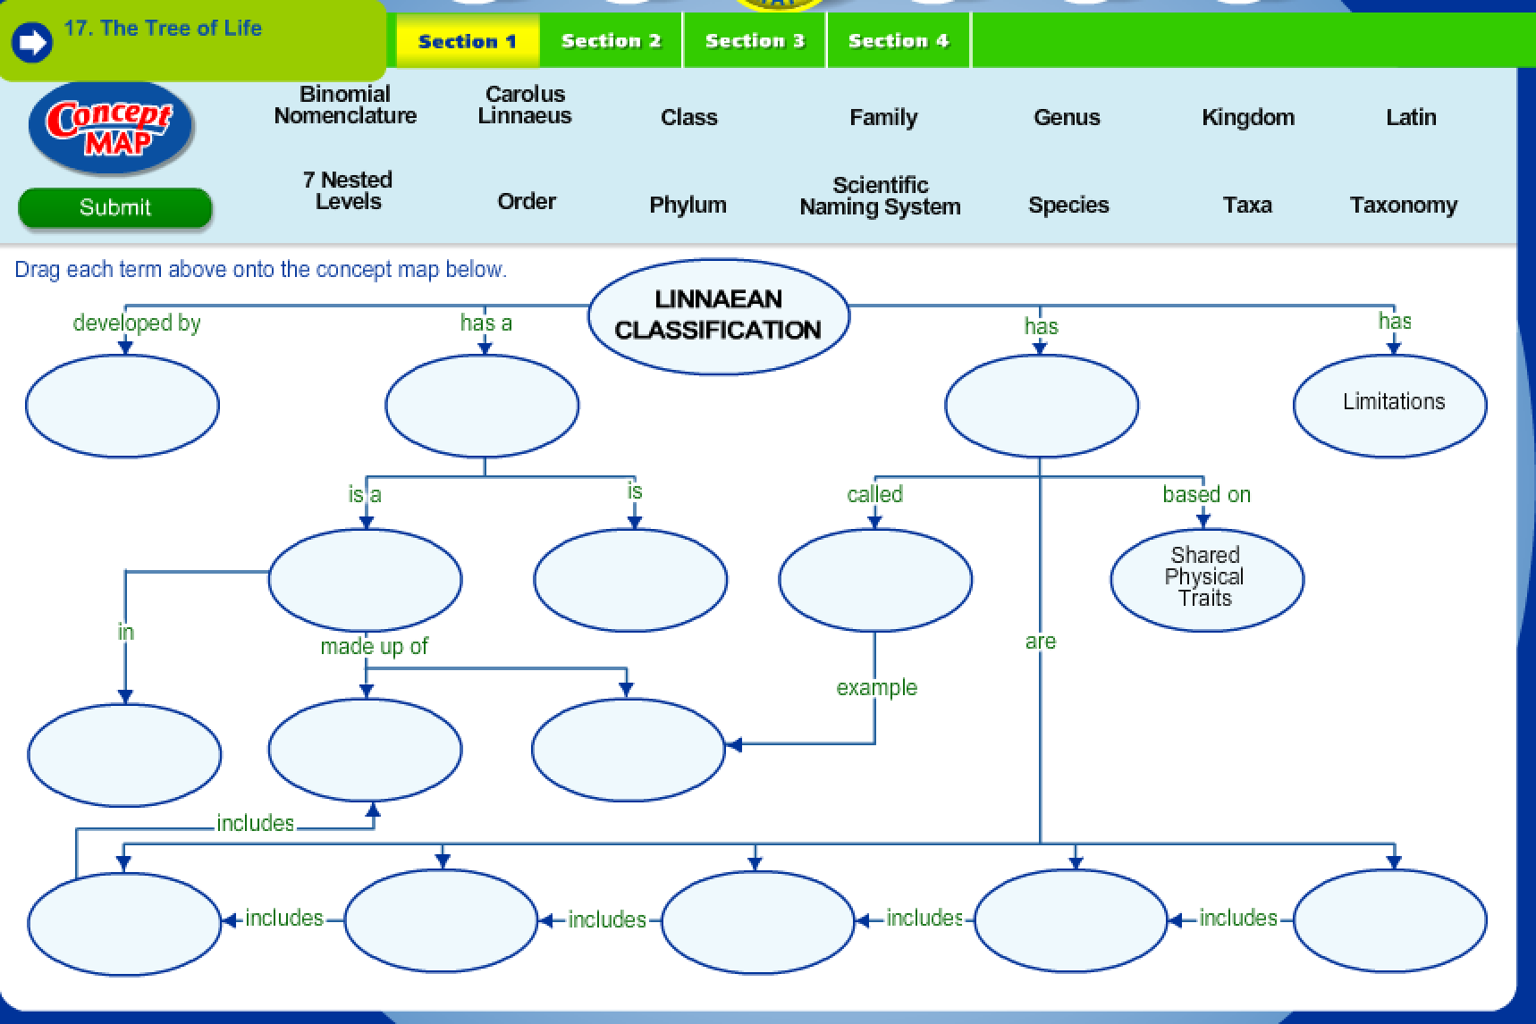

8.C Three Domains Graphic Organizer

